**PostgreSQL + Info-Gathering:**

**CMF - PostgreSQL Server Info-Gathering Automation for Linux - User Guide**

**For Script:**

**CMF-PostgreSQL_LinuxServer_Info_Gathering.ps1**



**Document Summary**

|  |  |
| --- | --- |
| **Document Item** | **Current Value** |
| Document Title | CMF - PostgreSQL Server Info-Gathering Automation for Linux - User Guide |
| Program | CSU Migration Factory |
| Date Last Modified | 25-Oct-2023 |
| Date Last Reviewed | 25-Oct-2023 |
| Current Document Known Issue | N/A |
| Status | Initial |
| Document Description | This document provides the procedure/steps to execute the Automation script which gathers the PostgreSQL server details from Linux environment. |

**Revision History**

This section represents the change history of the document. Revisions of the document must be tracked by identifying a new version number, the date it was modified, the person making the change, and the reason for the change.

|  |  |  |  |  |
| --- | --- | --- | --- | --- |
| Date | Version | Change Description | Author | Reviewer |
| 25-Oct-2023 | 1.0 | Initial Version | Lekshmy, Arun, Mukesh, Chethan | Rackimuthu Kandaswamy |

Contents

Executive Summary 4

1.1 Objective 4

1.2 Recommendations 4

2 Prerequisites for PostgreSQL_LinuxServer_Info_Gathering - Execution. 4

Non-Mission-Critical system 4

2.1 Input Excel File 5

2.2 PowerShell Installation on Linux 7

3 Copying Script 7

3.1 Folder Name 7

3.2 Script and Input file 7

4 Executing the Script 8

4.1 PostgreSQL Server Automation execution 8

4.1.1 Create support folders (Logs, Output, Downloads etc) and Validate ImportExcel Module 9

4.2 Automation Script Transcript Log 10

4.3 Final Output 11

# Executive Summary

## Objective

This document provides the procedure/steps to execute the Automation script (CMF-PostgreSQL_LinuxServer_Info_Gathering.ps1) which gathers the PostgreSQL Server details from Linux environment.

## Recommendations

Key recommendations are as follows:

1. Run the script on Non-Mission-Critical systems ONLY (i.e.**NOT** on any production server)
2. Connectivity must exist between the SYSTEM which runs the PostgreSQL Server Info Gathering Automation script
3. Powershell 5.1 version

# Prerequisites for PostgreSQL_LinuxServer_Info_Gathering - Execution.

## Non-Mission-Critical system

* **Don't install and run the Automation scripts on any mission-critical production server.**

## Input Excel File

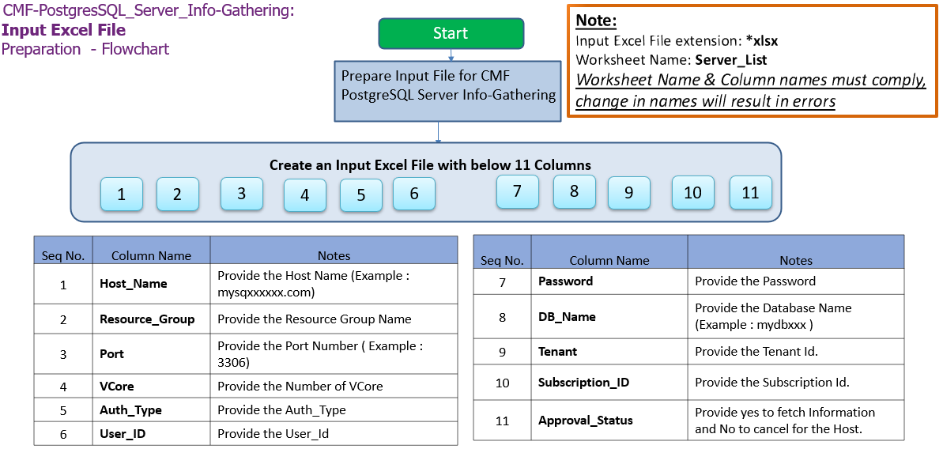

**Important Notes:**

* PostgreSQL Client is required to establish Connectivity to PostgreSQL Servers.
* This script is based on the Excel file named ‘CMF-PostgreSQL_Server_Input_file.xlsx’.
* Worksheet name in the INPUT EXCEL FILE must be ‘Server_List’**.**
* **Column Name must be kept as shown below, change in names will result in errors**
* **Values in the column must be correct, incorrect values will also result in errors**
* **Port, tenant and Subscription_ID columns are Optional.**
* If there is only one server/instance to be assessed using the script, please add a duplicate line with same server information to avoid an input related issue

1. **Columns for Input File: CMF-PostgreSQL_Server_Input_file.xlsx**

|  |  |
| --- | --- |
| **Column Name** | **Note** |
| **Host_Name** | **Provide Host Name (Example: localhost)** |
| **Resource_Group** | **Provide the Resource Group Name (Optional)** |
| **Port** | **Provide Port Number (Example: 3306)** |
| **VCore** | **Provide the Number of VCore** |
| **Auth_Type** | **Provide the Auth_Type** |
| **User_ID** | **Provide the User_ID** |
| **Password** | **Provide the Password** |
| **DB_Name** | **Provide Database Name (Example:mysqldb)** |
| **Tenant** | **Azure Subscription tenant ID (Optional)** |
| **Subscription_ID** | **Azure Subscription ID (Optional)** |
| **Approval Status** | **Provide YES to fetch the information and NO to exclude the host.** |

|  |  |  |
| --- | --- | --- |
| **Seq.No** | **File** | **Note** |
| 1 |  | Sample: **CMF-PostgreSQL_Server_Input_file.xlsx** |

## PowerShell Installation on Linux

|  |
| --- |
| # Register the Microsoft RedHat repository  curl https://packages.microsoft.com/config/rhel/7/prod.repo | sudo tee /etc/yum.repos.d/microsoft.repo  # Install PowerShell  sudo yum install –assume yes powershell  # Start PowerShell  Pwsh |

# Copying Script

## Folder Name

* Login into a Non-Mission-Critical system (i.e.**NOT**on any production server) from where the PostgreSQL Server Automation is to be run
* Create a folder named PostgreSQL.

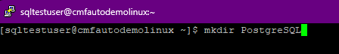

## Script and Input file

* Copy the content under the folder created in the previous step.

# Executing the Script

## PostgreSQL Server Automation execution

* Open Putty, connect to the server and execute the script.

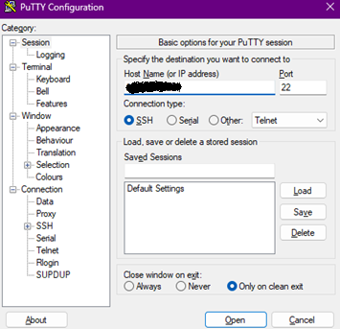

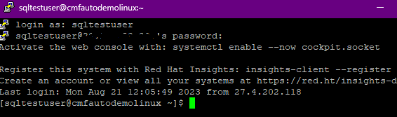

1. To execute PowerShell script from putty, type “pwsh” and press Enter.
2. Enter the following command to execute the script.

**./CMF-PostgreSQL_LinuxServer_Info_Gathering.ps1**

### Create support folders (Logs, Output, Downloads etc) and Validate ImportExcel Module

After triggering the automation all the support folders (Logs, Output, Downloads etc. ) will be created automatically by the automation script in the PostgreSQL folder

Automation script validates the ImportExcel module. If not found, automation will initiate installation.

* Enter Y to proceed with PostgreSQL Server Automation.

* Above are the list of Hosts that will proceed based on user selection.
* Enter Y to continue with the execution.
* The Script checks for PSQL path and initiates PostgreSQL Server Info-Gathering.

## Automation Script Transcript Log



**Note:** For the Automation, transcript will be generated in text format as above

## Final Output

